1 May 2020

Dear Lodge Member,

Re – RMBI Care Co during the Covid-19 Crisis

The RMBI Care Co has provided Care Homes for older Freemasons and their dependents for over 170 years. We have 18 Homes spread across the Country offering over 1,000 placements. The adverse national media coverage in the last few days regarding the impact of Covid-19 has been well reported.

Despite this we continue to remain open for new referrals be it for respite or permanent. All our Homes are fully compliant with our English and Welsh Regulators and well supported by local Freemasons through our Association of Friends.

We reacted quickly in early March to the warnings concerning the spread of Covid-19. This included immediate restrictions on visitors (and we thank relatives for being so understanding), daily temperature checks for all residents and staff, 14 day isolation for any resident with symptoms of Covid-19 or returning from hospital and importantly, the sourcing of adequate Personal Protective Equipment. We have also had several generous offers of support from Freemasons to the provision of local PPE supplies.

The limited number of residents with symptoms continue to make a full recovery and whilst we have had a small number of deaths related to Covid-19 we have had several good news stories of residents returning to full fitness and health.

We maintain regular communication with relatives to confirm how each home is doing and remain confident, despite the current adverse media reporting of the Care Sector, that the RMBI Care Co continues to operate within strict protocols which ensure the safety and security of our residents and excellent staff team. We also continue to communicate on a regular basis with Almoners to encourage new referrals and to update on each home.

We welcome referrals from the community be they from the Freemasons or the wider community and any enquires can be forwarded in the first instance to Debbie our Resident Placements’ Manager at dhollands@rmbi.org.uk who will be happy to answer your questions.

Please share our letter with fellow Lodge Members and families which will be appreciated.

Yours sincerely,
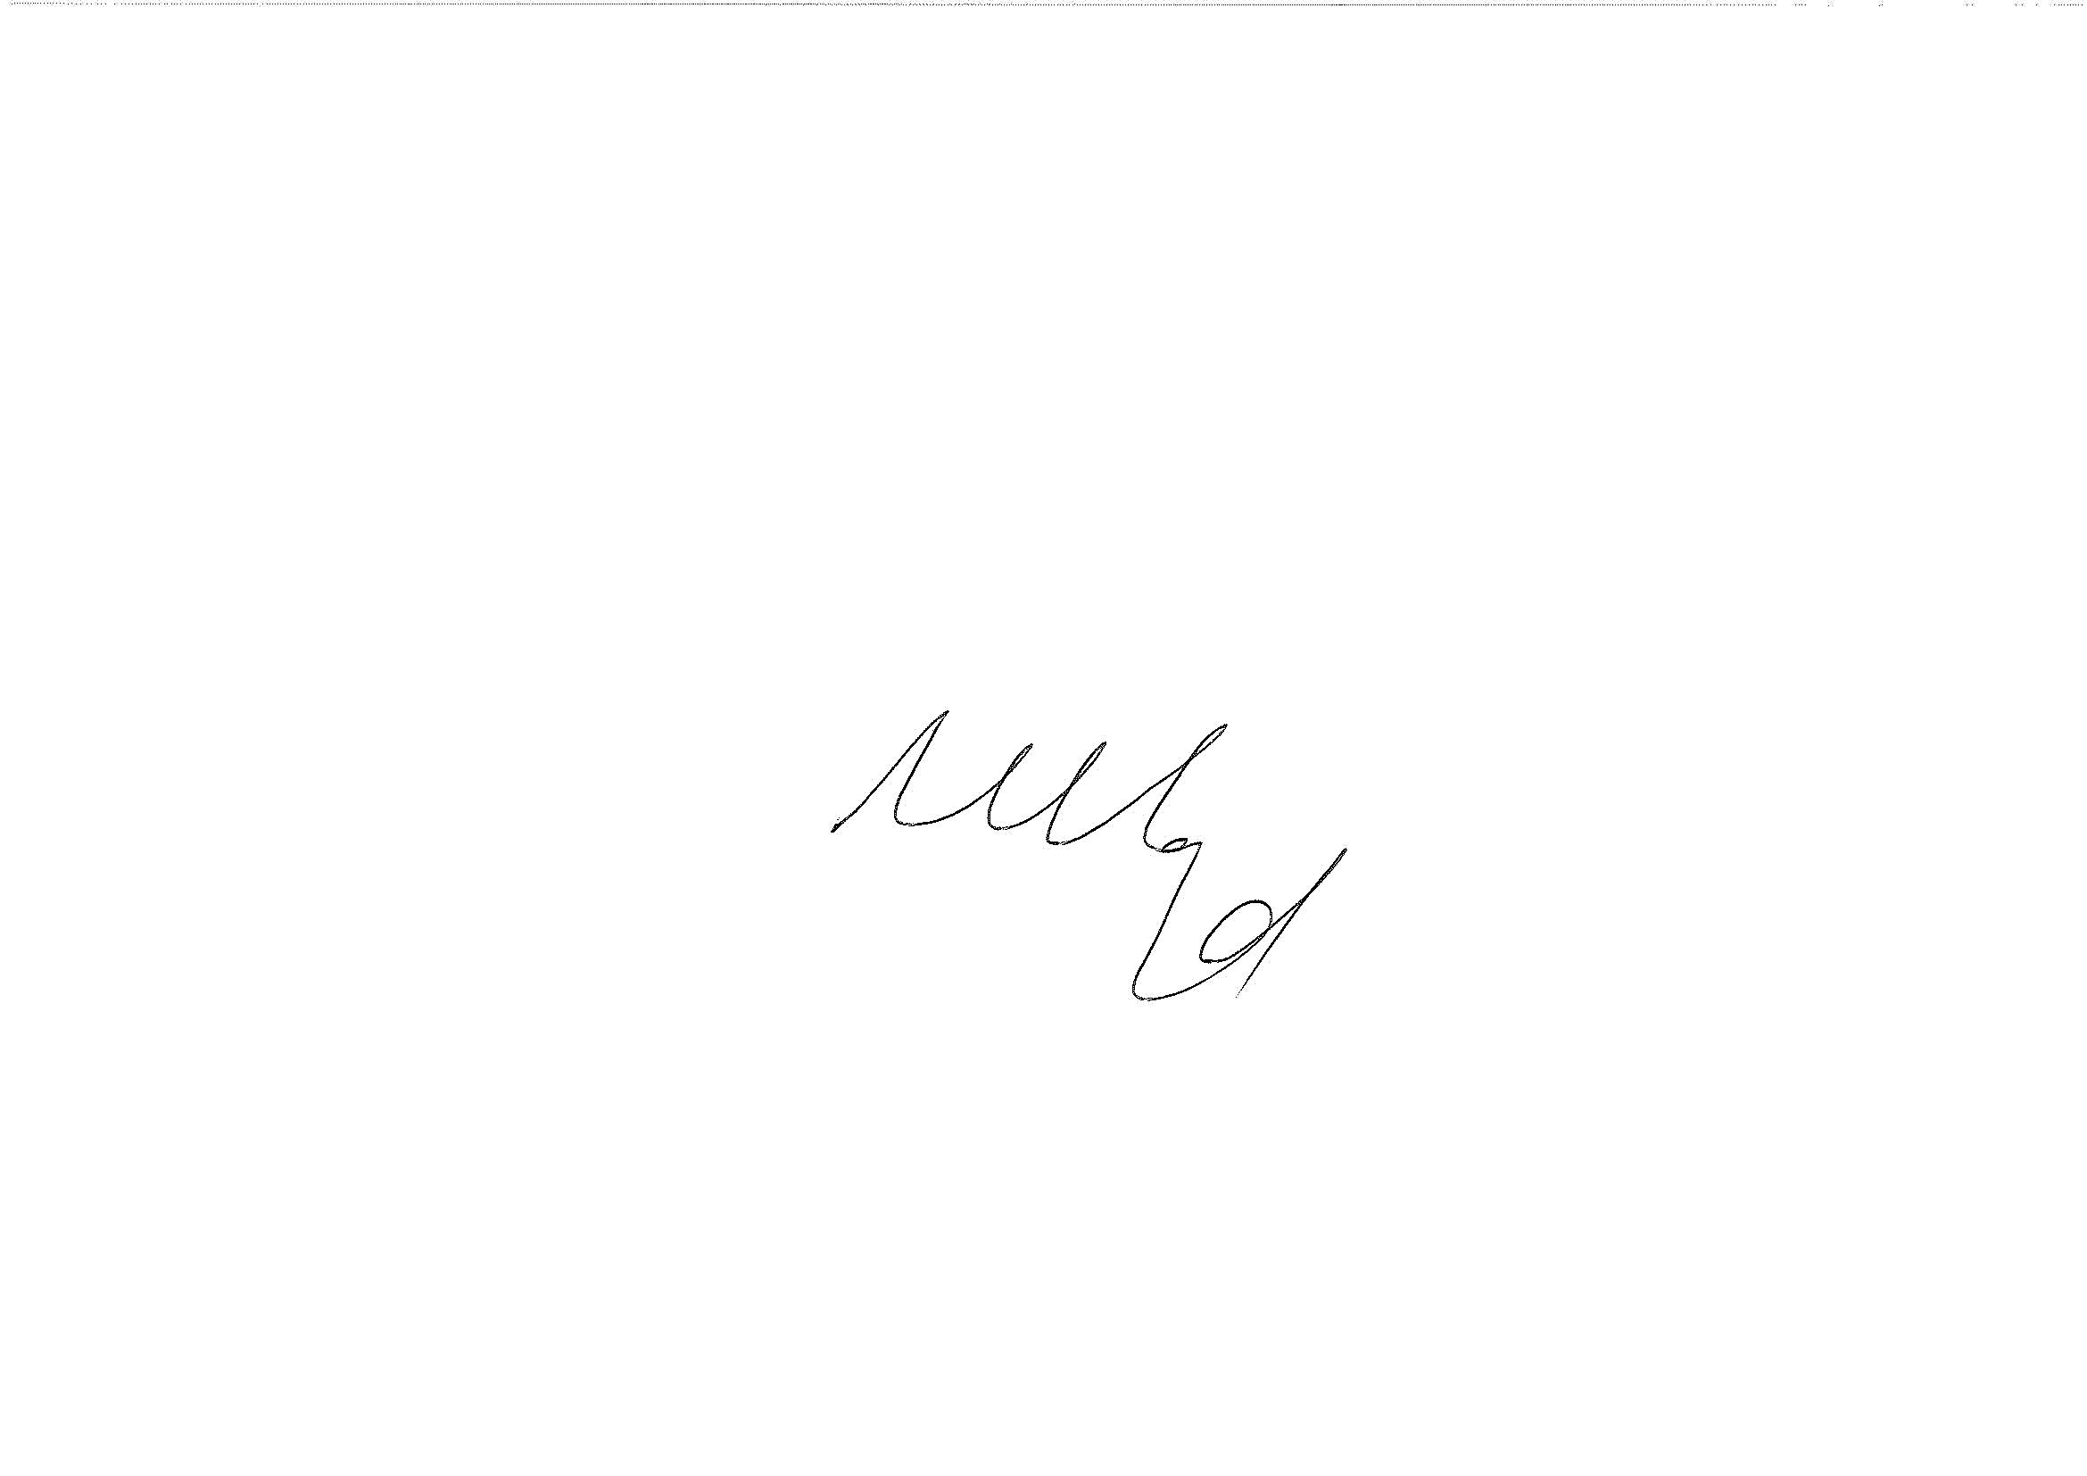

Mark LLoyd
Managing Director, RMBI Care Company

